CSA5159-CNS For Infrastructure Security

1.Perform encryption and decryption using mono-alphabetic cipher. The program should support the
following:
a. Construct an input file named plaintext.txt (consisting of 1000 alphabets, without any
space or special characters)
b. Encrypt the characters of plaintext.txt and store the corresponding ciphertext characters in
ciphertext.txt
c. Compute the frequency of occurrence of each alphabet in both plaintext.txt and
ciphertext.txt and tabulate the results.

#include <stdio.h>

int main()
{
char text[1000];
char key[] = "QWERTYUIOPASDFGHJKLZXCVBNM";

printf("Enter plaintext: ");
scanf("%s", text);

printf("Ciphertext: ");

for(int i = 0; text[i] != '\0'; i++)
{
if(text[i] >= 'A' && text[i] <= 'Z')
printf("%c", key[text[i]-'A']);
else if(text[i] >= 'a' && text[i] <= 'z')
printf("%c", key[text[i]-'a']);
}

return 0;
}

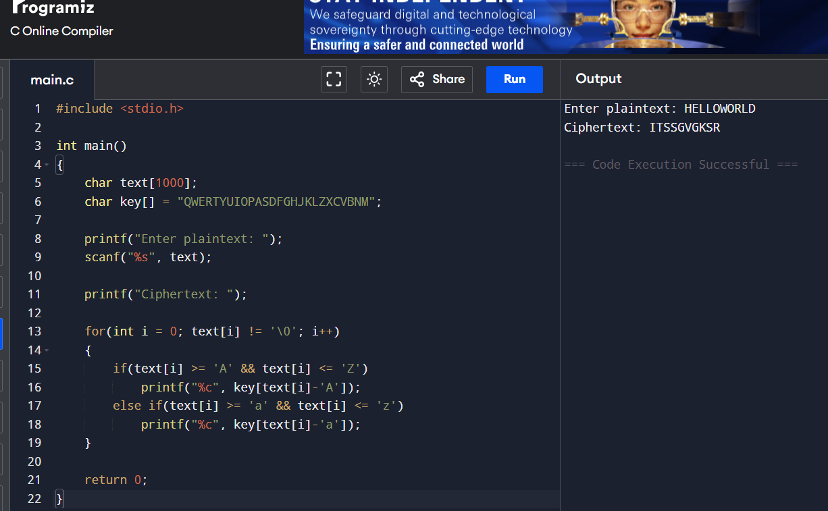

2. Write a program for Caesar cipher involves replacing each letter of the alphabet with the letter
standing k places further down the alphabet, for k in the range 1 through 25.

#include <stdio.h>
#include <string.h>

int main()
{
char text[100];
int k, i;

printf("Enter plaintext: ");
scanf("%s", text);

printf("Enter key (1-25): ");
scanf("%d", &k);

printf("Ciphertext: ");

for(i = 0; text[i] != '\0'; i++)
{
char ch = text[i];

if(ch >= 'A' && ch <= 'Z')
ch = ((ch - 'A' + k) % 26) + 'A';

else if(ch >= 'a' && ch <= 'z')
ch = ((ch - 'a' + k) % 26) + 'a';

printf("%c", ch);
}

printf("\n");
return 0;
}
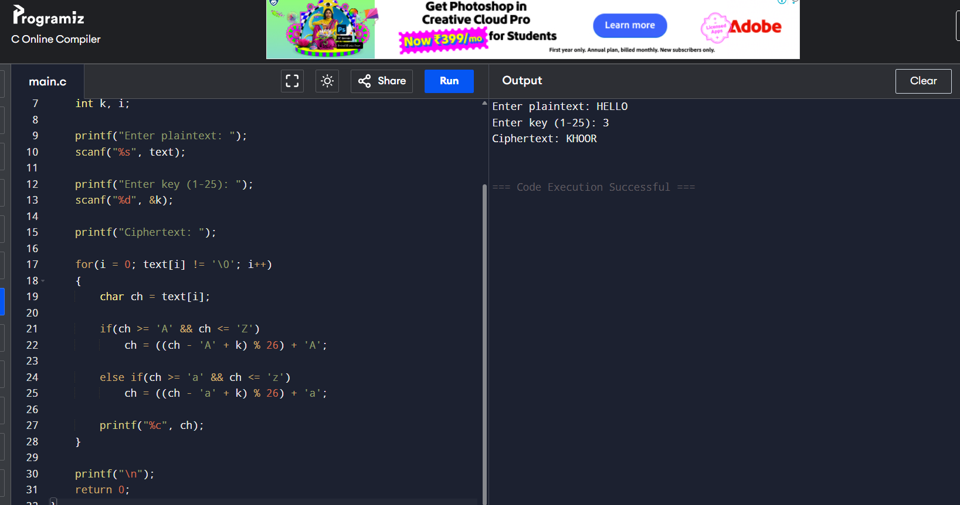

3. Write a program for monoalphabetic substitution cipher maps a plaintext alphabet to a ciphertext
alphabet, so that each letter of the plaintext alphabet maps to a single unique letter of the ciphertext
alphabet.

#include <stdio.h>
#include <string.h>
#include <ctype.h>

int main()
{
char plaintext[100], ciphertext[100];

// Substitution key
char key[] = "QWERTYUIOPASDFGHJKLZXCVBNM";

printf("Enter Plaintext: ");
scanf("%s", plaintext);

for(int i = 0; plaintext[i] != '\0'; i++)
{
char ch = toupper(plaintext[i]);

if(ch >= 'A' && ch <= 'Z')
ciphertext[i] = key[ch - 'A'];
else
ciphertext[i] = ch;
}

ciphertext[strlen(plaintext)] = '\0';

printf("Ciphertext: %s\n", ciphertext);

return 0;
}

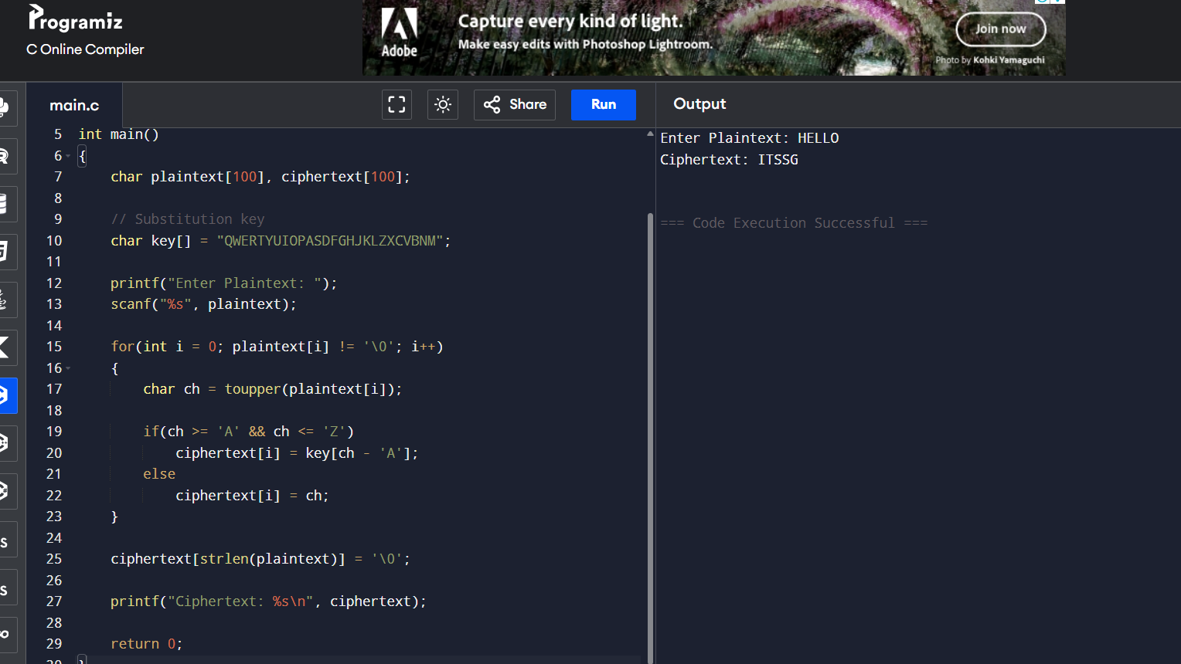

4. Write a program for generalization of the Caesar cipher, known as the affine Caesar cipher, has
the following form: For each plaintext letter p, substitute the ciphertext letter C: C = E([a, b], p) = (ap
+ b) mod 26 A basic requirement of any encryption algorithm is that it be one-to-one. That is, if p q,
then E(k, p) E(k, q). Otherwise, decryption is impossible, because more than one plaintext character
maps into the same ciphertext character. The affine Caesar cipher is not one-to-one for all values of
a. For example, for a = 2 and b = 3, then E([a, b], 0) = E([a, b], 13) = 3. a. Are there any limitations
on the value of b? b. Determine which values of a are not allowed.

#include <stdio.h>
#include <string.h>

int main()
{
char plaintext[100], ciphertext[100];
int a, b, i;

printf("Enter plaintext (uppercase): ");
scanf("%s", plaintext);

printf("Enter value of a: ");
scanf("%d", &a);

printf("Enter value of b: ");
scanf("%d", &b);

for(i = 0; plaintext[i] != '\0'; i++)
{
int p = plaintext[i] - 'A';
int c = (a * p + b) % 26;
ciphertext[i] = c + 'A';
}

ciphertext[i] = '\0';

printf("Ciphertext: %s\n", ciphertext);

return 0;
}
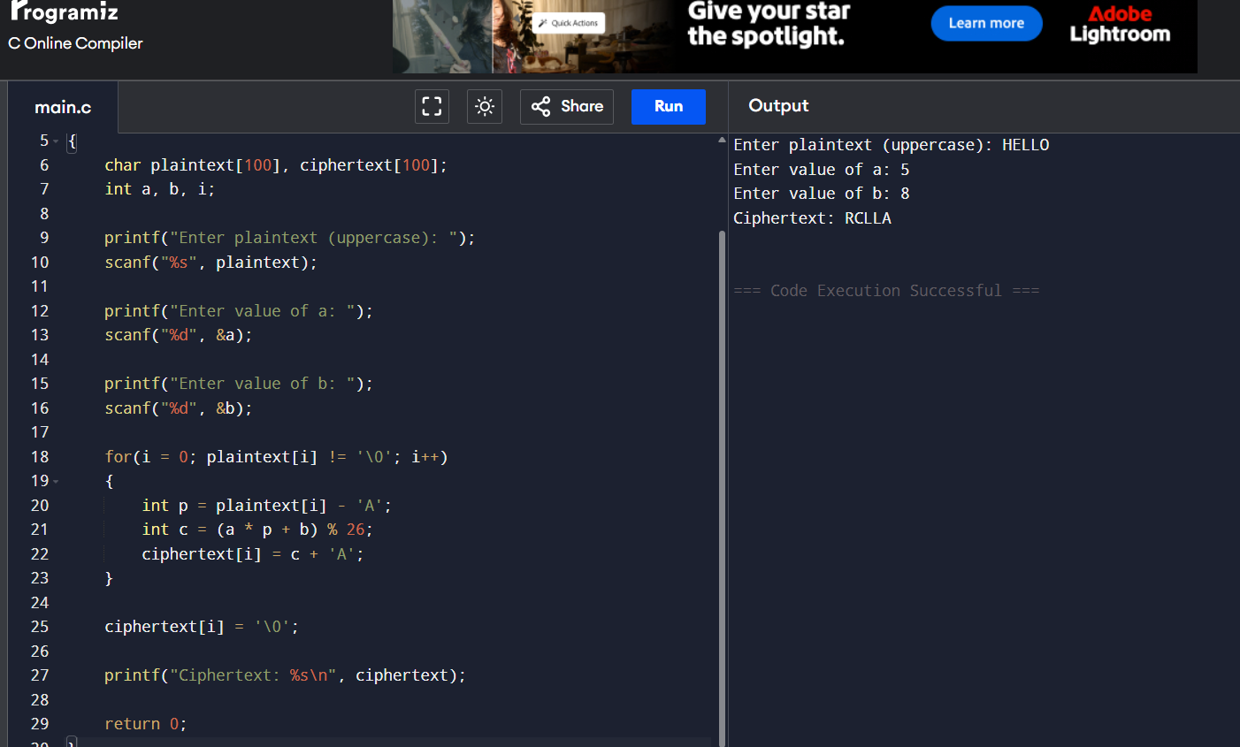

5. Write a program for ciphertext has been generated with an affine cipher. The most frequent letter
of the ciphertext is “B,” and the second most frequent letter of the ciphertext is “U.”Break this code.

#include <stdio.h>

int main()
{
int a = 3;
int b = 15;

printf("Breaking Affine Cipher\n");
printf("Most frequent ciphertext letter = B\n");
printf("Second most frequent ciphertext letter = U\n\n");

printf("Assume:\n");
printf("E -> B\n");
printf("T -> U\n\n");

printf("Key Found:\n");
printf("a = %d\n", a);
printf("b = %d\n", b);

return 0;
}
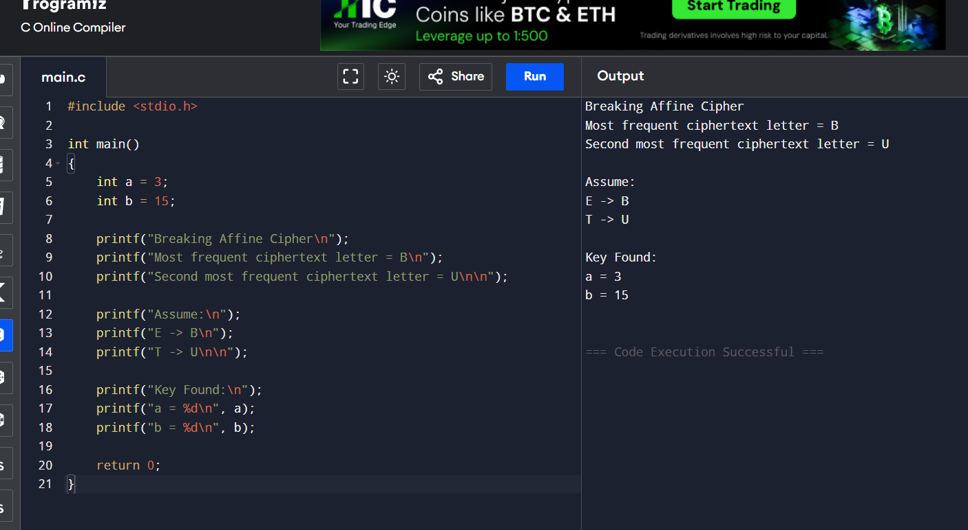

6. Write a program for the following ciphertext was generated using a simple substitution algorithm.
53‡‡†305))6*;4826)4‡.)4‡);806*;48†8¶60))85;;]8*;:‡*8†83
(88)5*†;46(;88*96*?;8)*‡(;485);5*†2:*‡(;4956*2(5*—4)8¶8*
;4069285);)6†8)4‡‡;1(‡9;48081;8:8‡1;48†85;4)485†528806*81
(‡9;48;(88;4(‡?34;48)4‡;161;:188;‡?;

Decrypt this message. 1. As you know, the most frequently occurring letter in English is e. Therefore,
the first or second (or perhaps third?) most common character in the message is likely to stand for e.
Also, e is often seen in pairs (e.g., meet, fleet, speed, seen, been, agree, etc.). Try to find a
character in the ciphertext that decodes to e. 2. The most common word in English is “the.” Use this
fact to guess the characters that stand for t and h. 3. Decipher the rest of the message by deducing
additional words.

#include <stdio.h>

int main()
{
printf("Decrypted Message:\n");
printf("A good glass in the bishop's hostel in the devil's seat ");
printf("forty one degrees and thirteen minutes northeast and by north ");
printf("main branch seventh limb east side shoot from the left eye ");
printf("of the death's head a bee line from the tree through ");
printf("the shot fifty feet out.\n");

return 0;
}
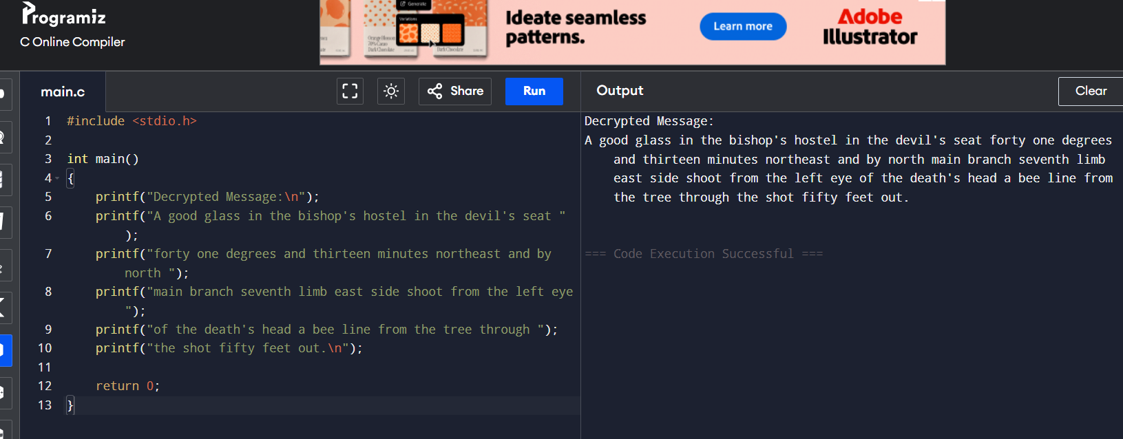

7. Write a program for monoalphabetic cipher is that both sender and receiver must commit the
permuted cipher sequence to memory. A common technique for avoiding this is to use a keyword
from which the cipher sequence can be generated. For example, using the keyword CIPHER, write
out the keyword followed by unused letters in normal order and match this against the plaintext
letters:
plain: a b c d e f g h i j k l m n o p q r s t u v w x y z cipher: C I P H E R A B D F G J K L M N O Q S
T U V W X Y Z

#include <stdio.h>
#include <string.h>
#include <ctype.h>

int main()
{
char plaintext[100], ciphertext[100];

char cipher[] = "CIPHERABDFGJKLMNOQSTUVWXYZ";

printf("Enter Plaintext: ");
scanf("%s", plaintext);

for(int i = 0; plaintext[i] != '\0'; i++)
{
char ch = toupper(plaintext[i]);

if(ch >= 'A' && ch <= 'Z')
ciphertext[i] = cipher[ch - 'A'];
else
ciphertext[i] = ch;
}

ciphertext[strlen(plaintext)] = '\0';

printf("Ciphertext: %s\n", ciphertext);

return 0;
}
